TEAM4OIES

Feasibility Study

Version 1.0

Signature Block

COSC 4351 | Name Signature | Date
SE Javier Rivera
SE Linh Tong
SE Paul Miller

Document Control

Change History
Table 1: TLs entries (assigned work and due dates) before releasing to the team (all SQAs)
Revision | Name | Due Date | Description
1.A | TM Steven Pate | 02/08/2015 | Add your work to Document
1.B | TM Janaye Maggart | 02/08/2015 | Add your work to Document
1.C | DBA Logan Stark | 02/08/2015 | Add your work to Document
1.X | SQA Linh Tong | 02/09/2015 | Review Document
1.Y | SQA Paul Miller | 02/10/2015 | Review Document

Table 2: Entries when work completed (SVN Commit Comment matches Description)
Revision | Name | Completed Date | Description
1.A | TM & Name | XX/XX/XXXX | I …..
1.B | TM Janaye Maggart | 02/08/15 | I appended my feasibility study to the document
1.C | DBA & Name | XX/XX/XXXX | I …..
1.D | DBA Jainesh Mehta | Feb 08, 2015 | I added my feasibility study to the .doc
1.X | SQA & Name | XX/XX/XXXX | I reviewed Document
1.Y | SQA & Name | XX/XX/XXXX | I reviewed Document

Table 3: TL entry for RED DELIVERABLES (SVN Commit Comment matches Description)
Revision | Name | Due Date | Description
2.0 | TL Javier Rivera | 02/11/2015 | I changed Version to 2.0

Document Storage
This file is stored in SVN at https://svn.cs.uh.edu/svn/cosc4351/team4/TEAM PROJECT DELIVERABLES/Feasibility Study.doc.

Executive Summary

TEAM4OIES has been assigned to build Online International Evar System website which has large backend database of EVAR (EndoVascular aortic Aneurysm Repair) data. This is feasibility report from each member of TEAM4OIES, to help us build website and decide what type of technology and features we can use for our OIVS.

JAINESH FEASIBILITY STUDY

Good Example:
http://www.3mensio.com/product-3mensio-vascular.aspx
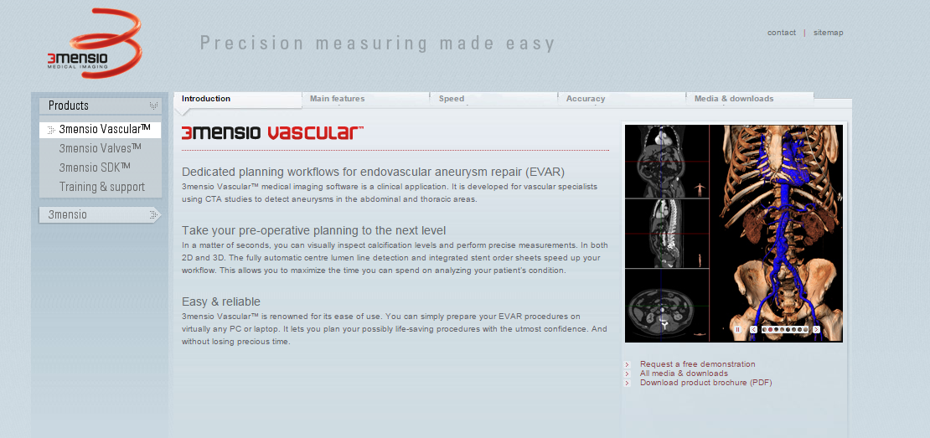
Easy to use Navigation menu and full of descriptions, also shows product/ procedures offered and their images.

Technologies Used:
- IIS 6
- ASP.NET
- jQuery
- Javascript

Cost: $9,545

Bad Example:
http://ncmc-hospital.com/



Annoying video plays every time at homepage, which can not be stopped or muted.
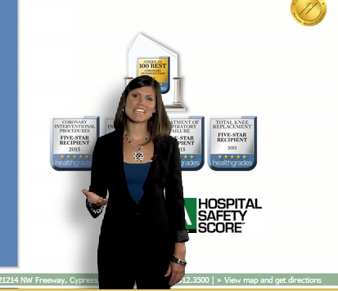
Technologies Used:
- IIS
- PHP
- jQuery
- Javascript

Cost: $8,188

JANAYE FEASIBILITY STUDY

Bad Example:
http://www.ikea.com/us/en/

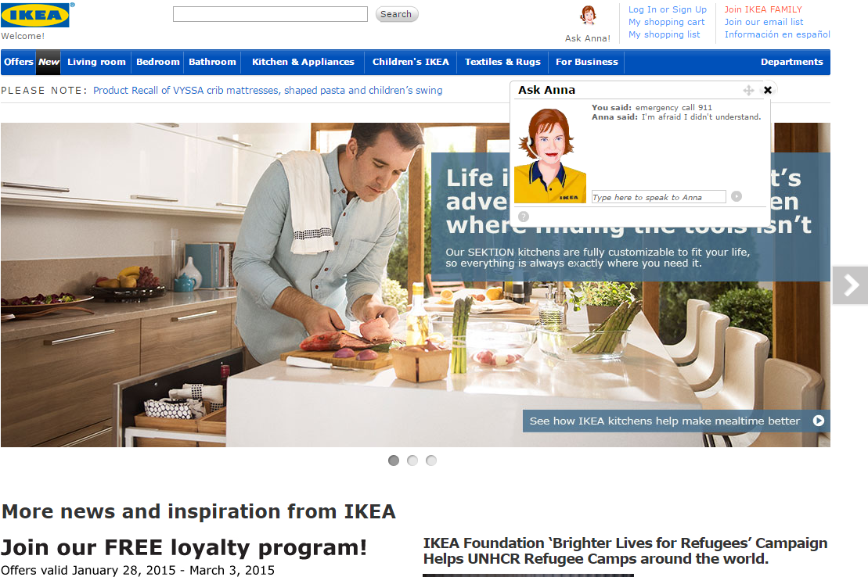

Website has chat function but chat is with AI which can get frustrating and waste of time.

Cost: 20,000
https://www-112.ibm.com/software/howtobuy/buyingtools/paexpress/Express?P0=E1&part_number=D55WVLL,D55WZLL,D57P1LL,D57P6LL,D1038LL,D103BLL,D103GLL&catalogLocale=en_US&Locale=en_US&country=USA&PT=jsp&CC=USA&VP=&TACTICS=&S_TACT=&S_CMP=&brand=SB05
Technologies:
- IBM Websphere Commerce
- J2EE
- Perl
- AJAX Libraries

Good Example:
http://www.earthlink.net/

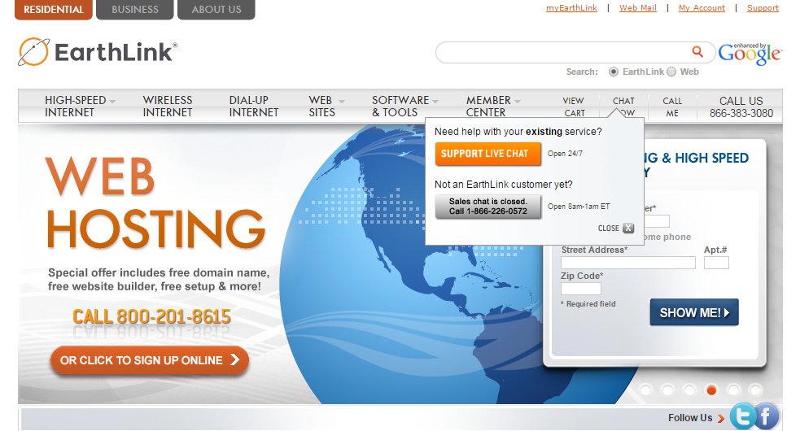

Home page has very good drop drown menu and provides Live Chat future with almost zero wait time. Also very easy to find contact phone number for support, which now days you have to dig through for most websites.

Cost: 30,000
Technologies:
- Apache
- J2EE
- Shockwave Flash Embed
- jQuery
________________________________________________________________________

